**WEDDING PLANNER**

*Developer Guide*

|  |  |  |
| --- | --- | --- |
| **Supervisor.** | **MISS MUNIBA** | |
| **Batch.** | **2110f1** | |
| **Group.** | A | |
| **Serial No.** | **Enrollment Number** | **Student Name** |
| 1. | 1340184 | ASHER AHMED |
| 2. | 1339931 | ALI |
| 3. | 1338691 | JUNAIAD |
| 4. | 1340161 | ZOYA |

1. **Home** (*index (1).html*)

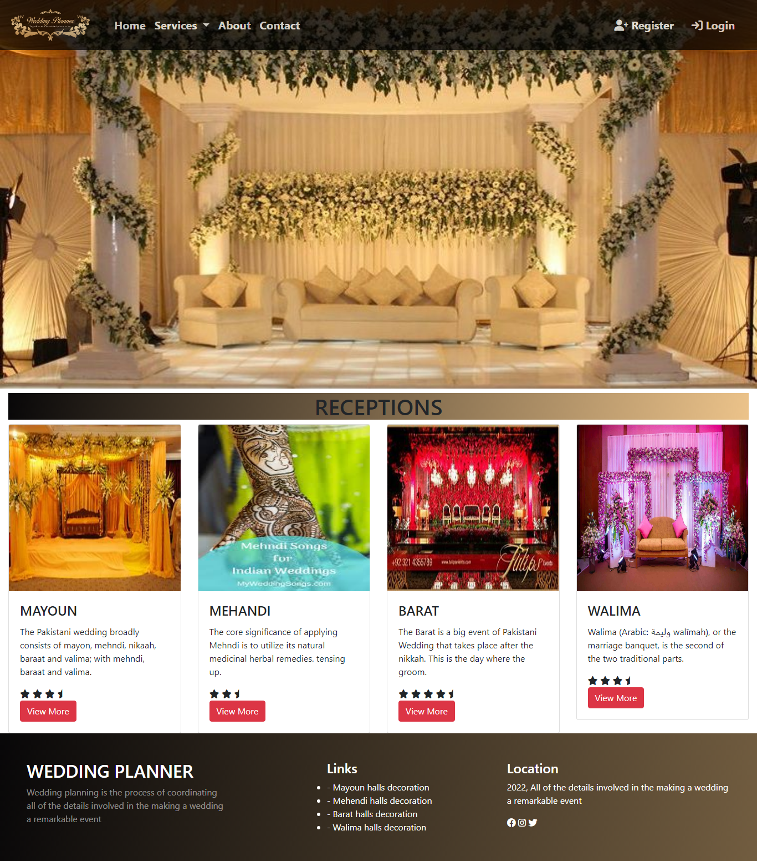

***Figure 1: Home page to wedding planner***

**Code of Home page**

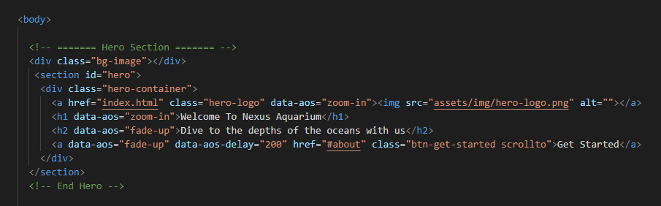

1. **Navbar (index (1).html)**

**

***Figure 2: Navbar***

* Our logo has given to the peoples toward our website. “WEDDING PLANNER”.
* By clicking (**NAV BAR**) button user while redirect to the main webpage.
* We have given six pages. By clicking any of the pages and redirect to the linked page. (0. index (1).html)

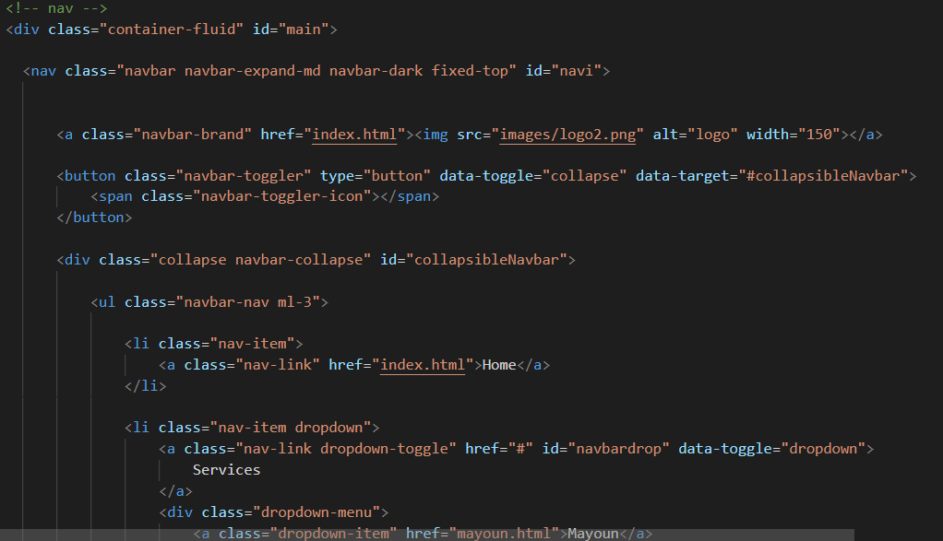 **Code of Navbar**

1. **About us (index (1).html)** 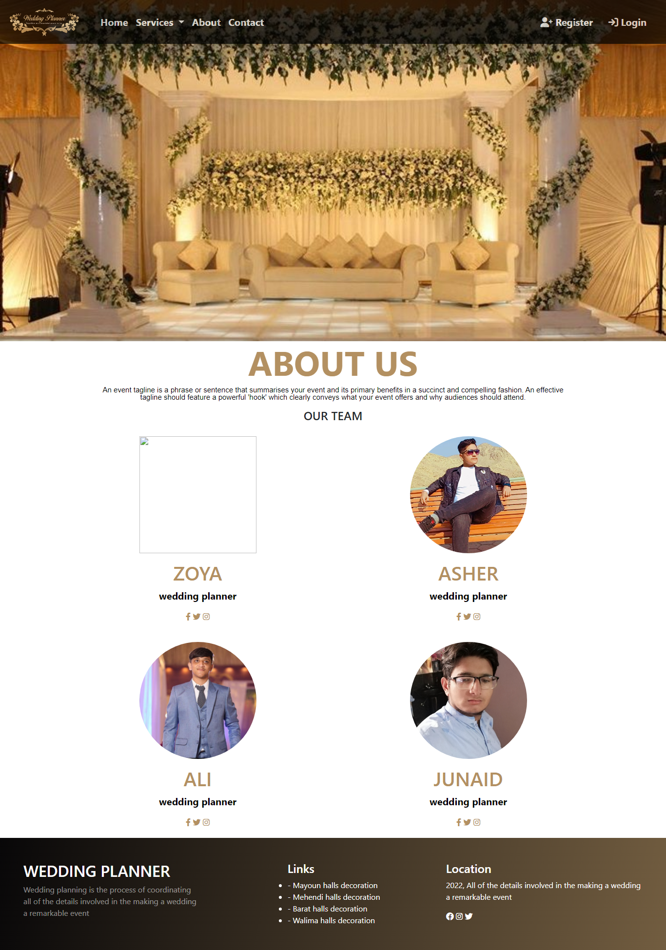

***Figure 3: About us***

* Explore different habitats, from the sweltering tropics to tidal rock pools.*

* Discover all about our weird and wonderful creatures with fun and interactive learning experience.*

***Code of About Us***

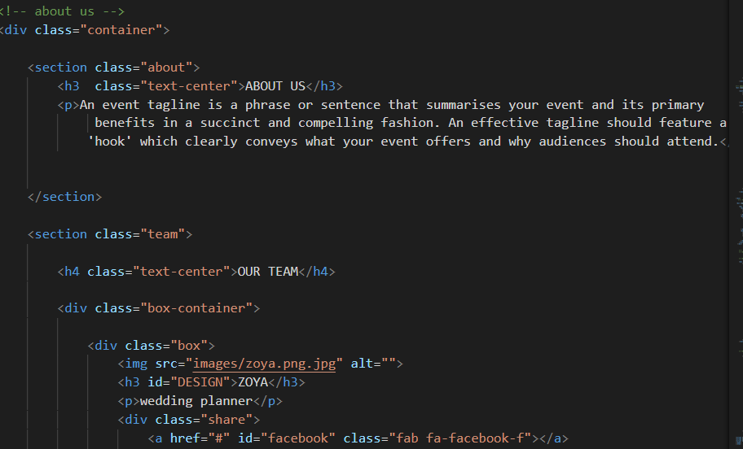

1. **services(index (1).html)**

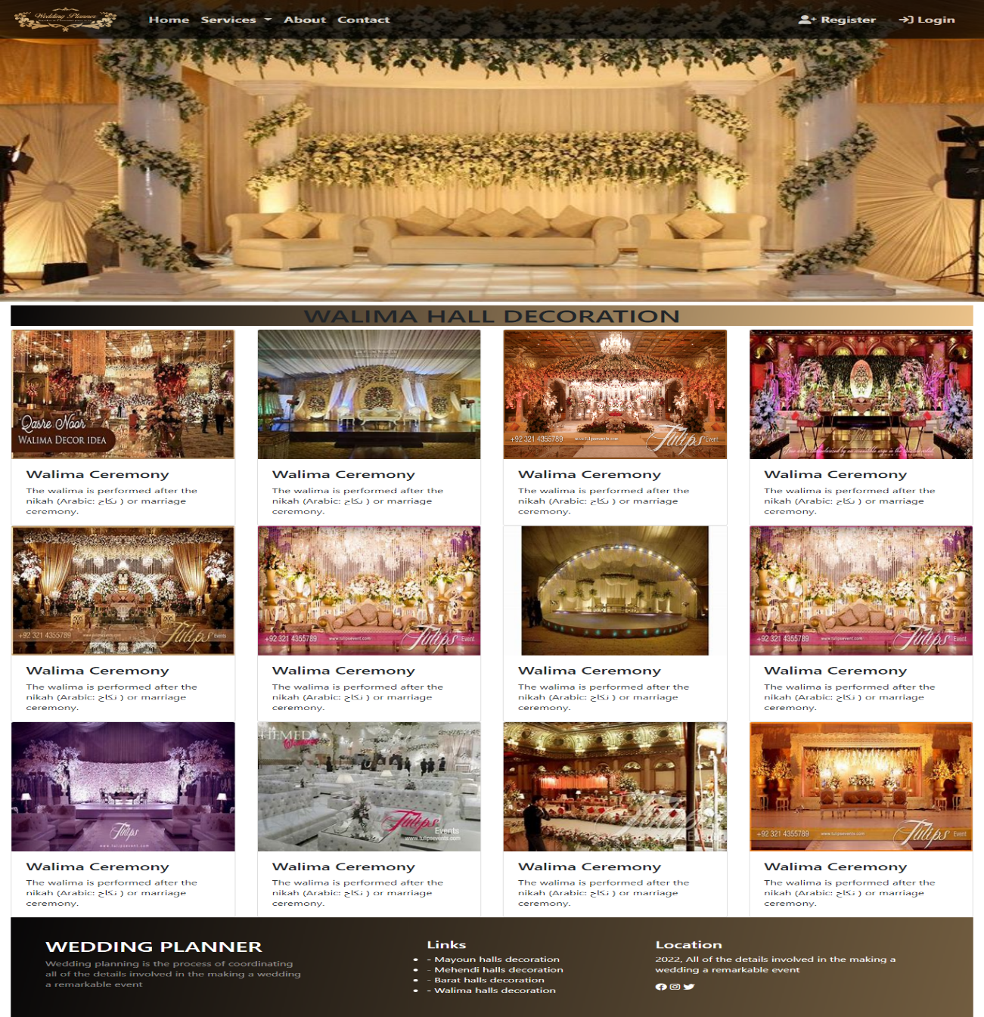

***Figure 4: Service***

*We have mentioned our basic services to make people known about the service we provide.*

** ***Home:*** *On our first service we have mentioned about providing home-based halls decoration and providing them chilled environment.*

* ***Cleaning Service:*** *We have mentioned that we are providing wedding hall cleaning services to the customer.*
* ***Customer Service:*** *For the ease of the people our website us providing customer service for the customer so that they can contact directly to our aquatic assistant*

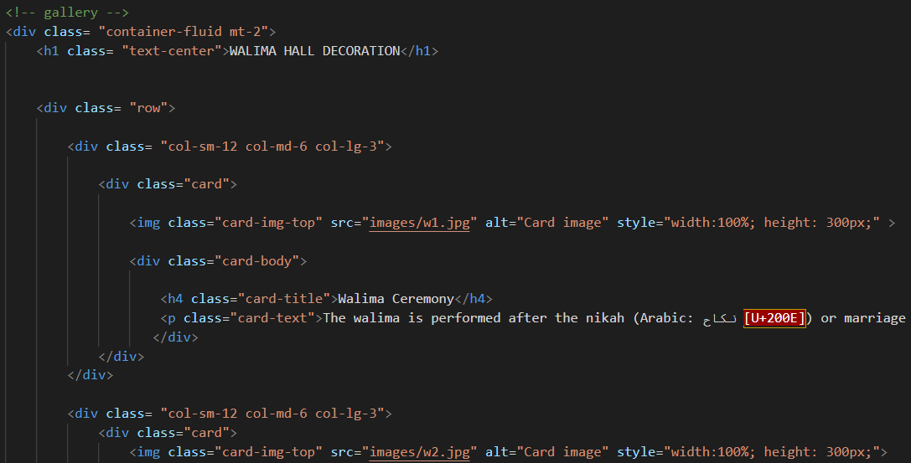***Code of Service***

1. ***Contact (index (1).html):***

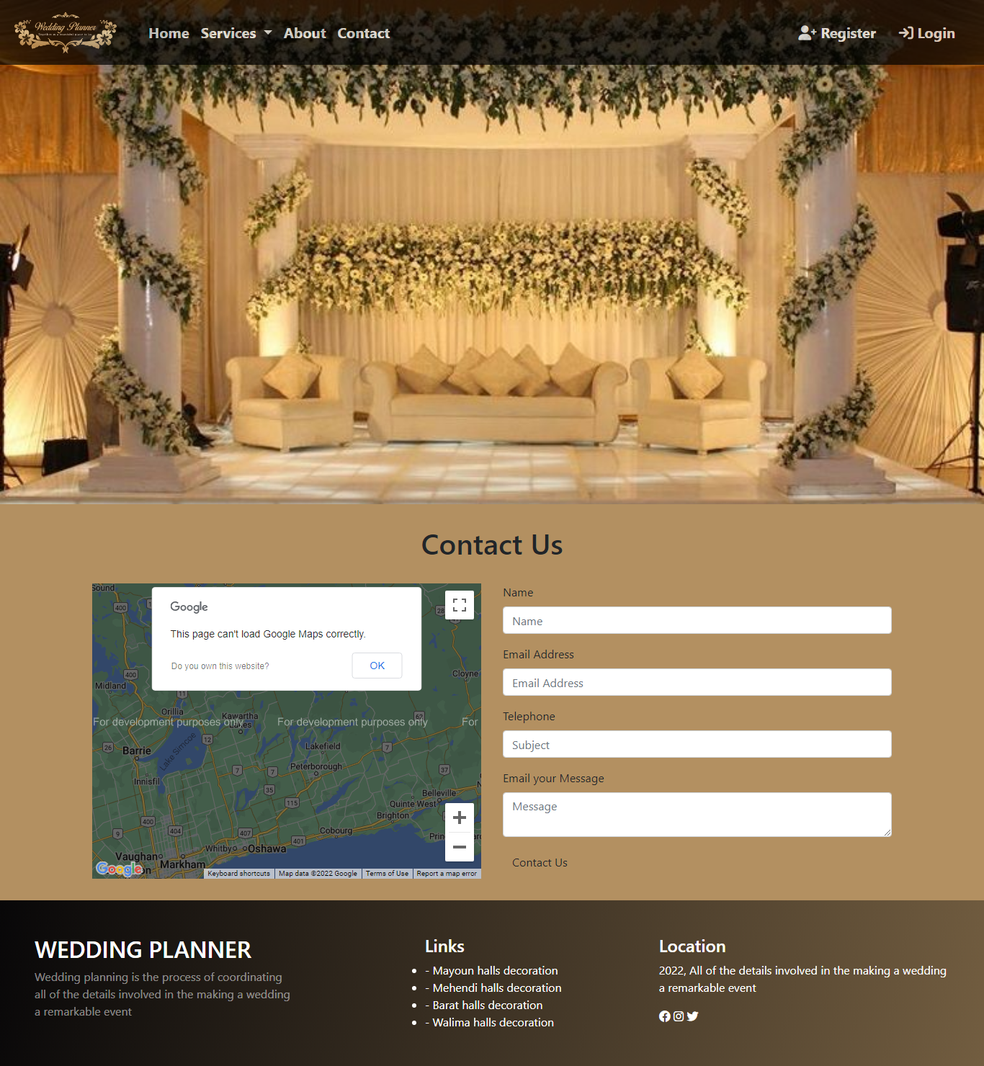

***Figure 13: Contact***

*In our contact section we have given location map for the ease of the people*

*Email id and phone number for contacting in case of any problem.*

*Contact Form:*

*To know the response of the people our team has given contact page for the ideas and feedback of the people.*

***Code of Contact***

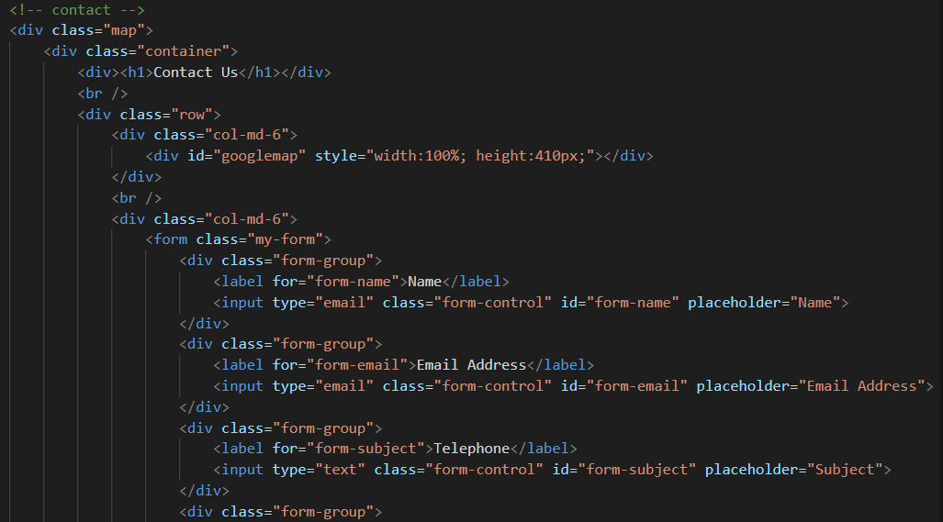

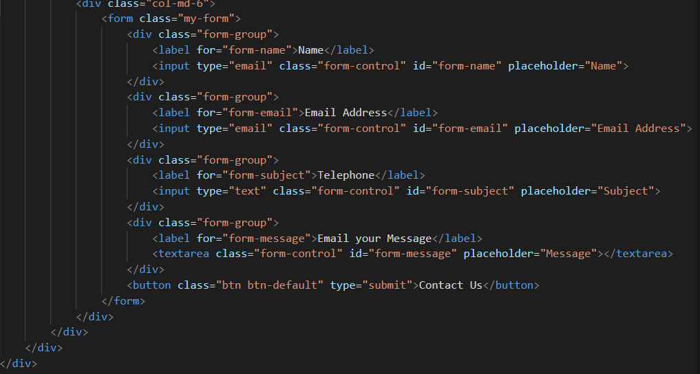

1. ***Inner Page(inner.html):***

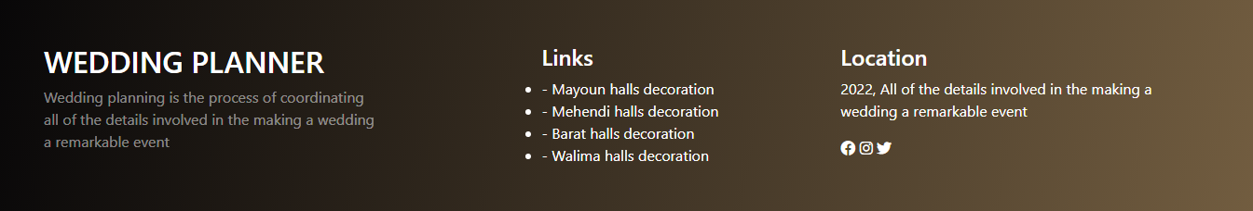

***Figure 14: Footer***

We have given some water bubbles animations in footer to make our website more relaxing. Copyrights are given in the end of the website and effects of Facebook Instagram and twitter are also mentioned for making the website attractive

***Code of footer:***

